**Session-14 Assignment**

**Name:-** Aryan Dilipbhai Langhanoja

**Enroll No:-** 92200133030

**AIM**: To understand Voltage Divider Bias to stabilize Q point of transistor.

**Objectives:**

1. To understand voltage divider bias circuit.
2. To design voltage divider bias circuit for transistor amplifier and investigating stability.

**Apparatus:**

1. Function generator
2. Dc power supply
3. Switch
4. Transistor (BC547)
5. Capacitor
6. Resistors
7. Oscilloscope

**Task-1-** Voltage Divider Bias

**Sample Circuit diagram:**



**Important Relation:**

**VB =** (R2)/(R1 + R2) VCC  = Vth

**VC=** VCC - ICRC

**VE=** IERE

**IB=** (Vth – VBE) / Rth + (1 + β ) RE

**IC=** βIB

**IE=** (β + 1) IB

**VCC=** I1R1 + I2R 2

**VCE= VCC** – IC (RC + RE)

**Multisim Circuit:**

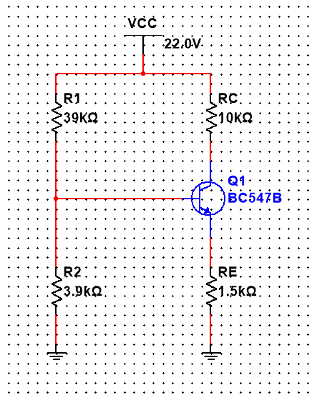

**Conclusion:**